Task 2:

The video games sales (see attached) dataset contains sales data for video games from all around the world, across different platforms, genres, and regions. Armed with this data and analysis, future developers can better understand what types of gameplay and mechanics resonate more with players to create a new gaming experience. Undertake a comprehensive analysis to produce a report on

* Insights on what games are successful (hit) across the globe
* What other things can we learn from this dataset
* Submit your code and report via the GitHub repo

The Describe the data

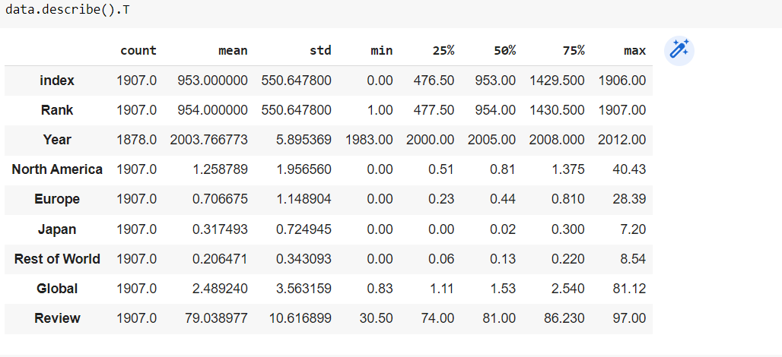

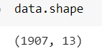

The Dataset will be 1907 of the columns on the 13 attributes of the datas

Data Cleaning

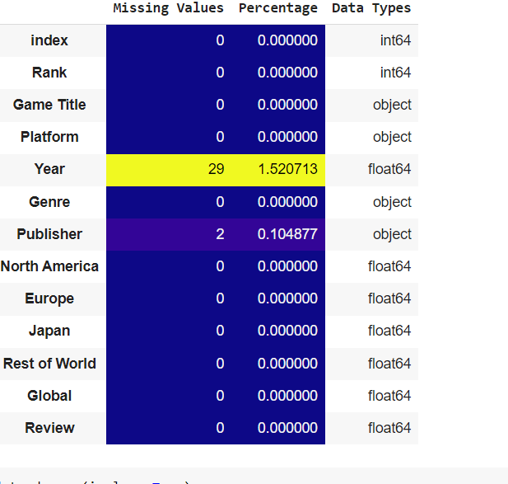

The affected om the data frame on the

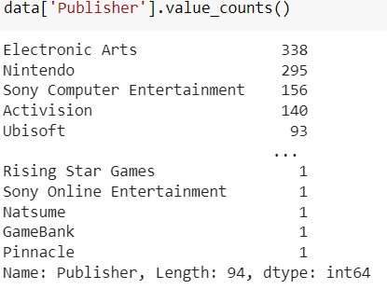 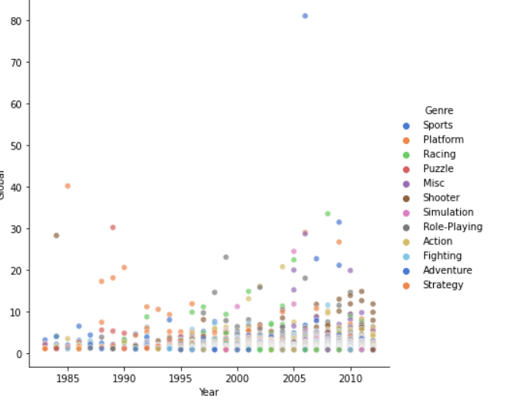

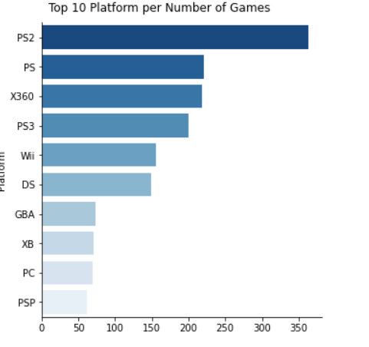

The Most of the country’s on the games on the platform in the most of the people of the games on the ps the frame

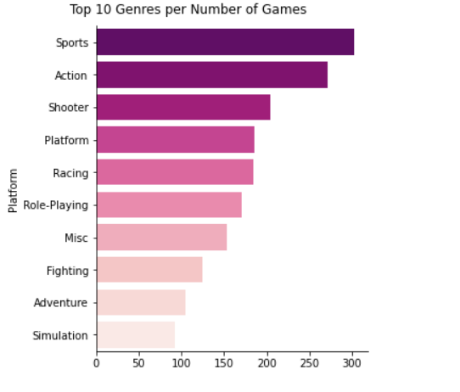

The on the sports on the frame work to the sports on the repostry